**Bank System(for Kids)**

**Introduction**: The idea of ‘Bank’ Software is to bring awareness in kids about Banks and to make the kids recognize basic bank operations. Its main features are described below to assist and demonstrate the software diagram, flow and complete process cycle,

1. **Bank Layout At Kid’s Dunya**
2. **Work Flow Of The Software**
3. **User Roles In The System**
4. **Modules**

**a. Layout At Kids Dunya**

## 

## b. Work Flow Of The Software

The flow of the software is workable with all hardware and software implementation. When a kid along with his group is entered in the ‘Kid’s Dunya’, the flow is started with the following number of steps:

1. **User Registration:**  First attempt of a KID is to register his group at KIOS. Here, the group is assigned by a reference code which is identical.



1. **Counter Wait:**  After a group is registered, it is verified by the system.



1. **NFC Band Assigning:**



A registered group has to own NFC band so that one of the group’s kid is enabled to possess a bank account.

Here the process undergoes into two strategies, one is that the group’s kid is already an account holder and on the other hand group haven’t any bank account.

If the group is account holder, it means it is ready to enter in activity area along with their NFC bands. On the other hand, the group’s kid will open a bank account.

1. **Open A Bank Account:** To open a bank account any kid of the group holding his info along with his NFC Band, will punch his band over an NFC Reader in

order to have/open a bank account.



1. **Process Flow Completion:** Now the group is prepared to be a part of the ‘Kid Dunya’.

## c. User Roles In The System

The software is accessible for the specific roles of users. The roles specification is defined below:

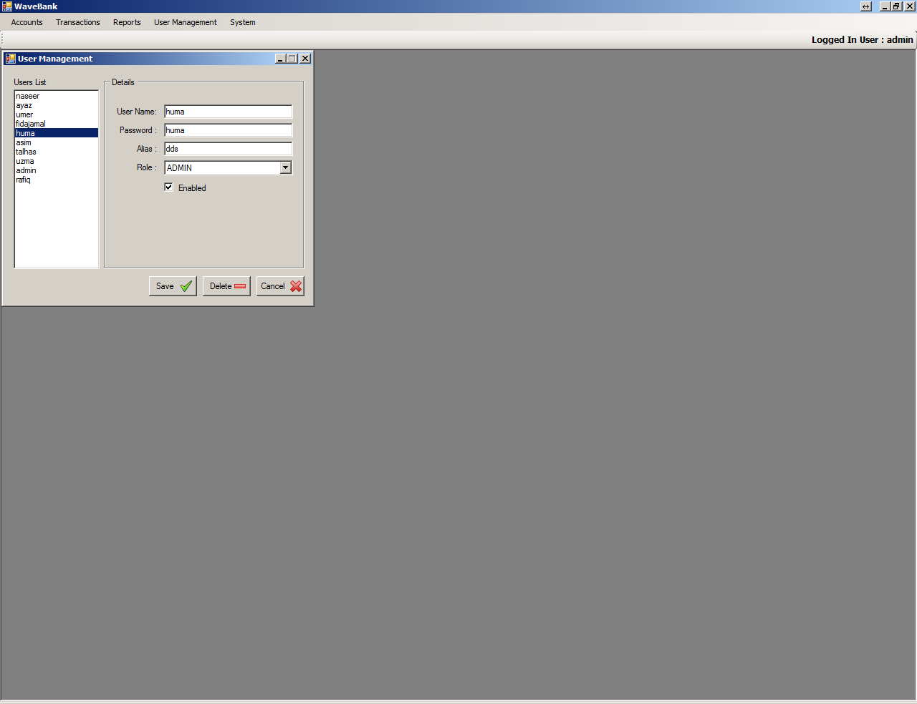

* **Administrator:** The user with role ‘Administrator’ can only create user.
* **Manager:** The user with role ‘Manager’ can perform majority of operations like account creation, deposit, withdrawal, and the balance inquiry.
* **Teller:** The user with role ‘Teller can only deposit, withdrawal, and check/inquiry the balance.
* **Statement Reporter:** The user with role ‘Statement Reporter’ can only view reports.

## d. Modules

Following are the basic modules of the bank system:

1. Account Creation
   1. Account Opening/Closing
   2. Account Lookup
2. Transaction
   1. Deposit
   2. Withdrawal
   3. Balance Inquiry
3. Reports
   1. Account Creation/Information Report
   2. Statement Report
   3. Balance Inquiry Report
   4. Specific Account Report

**ACCOUNT CREATION**

The software ‘Bank System’ makes very simple User Interface for our customers to manage accounts, including account creation, modification, and account lookup using variety of filters like Name, Account No., Contact Number, and their Account Status.

1. **Account Opening/Closing:** Using the software ‘Bank System’ our customer is facilitated with simple and convenient interface to open new account or to close

an existing account.

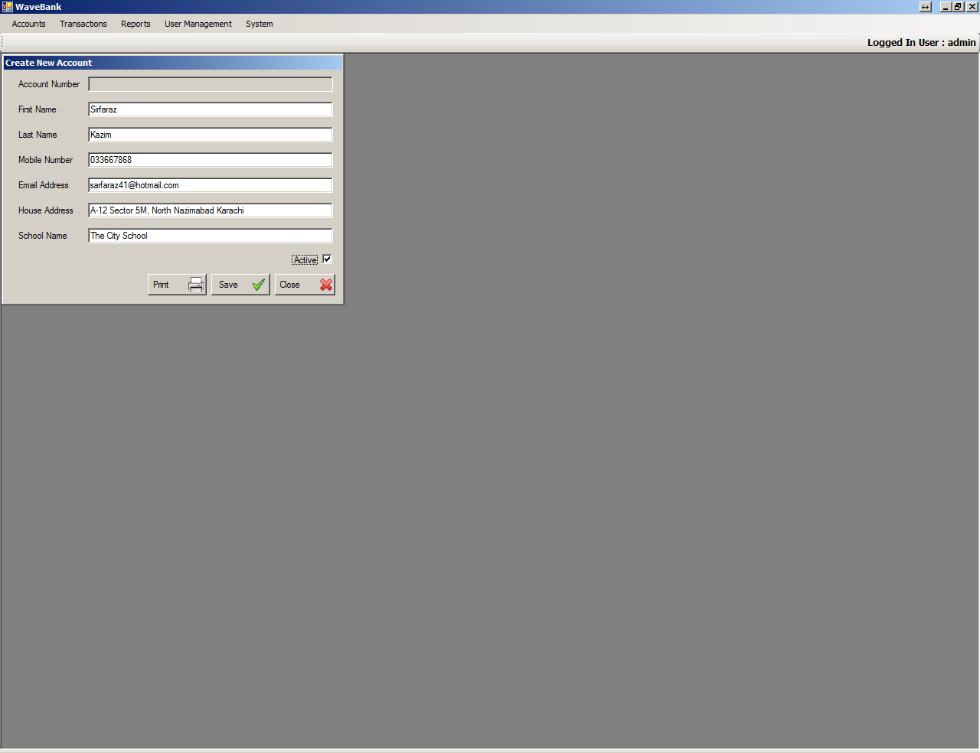

In this interface account is closed when the status check “Active ” is selected, in other case account is not considerable to make any transaction.

The interface not only open/close an account but also display the newly created account report. In order to get its report user will simply press the ‘Print’

button.

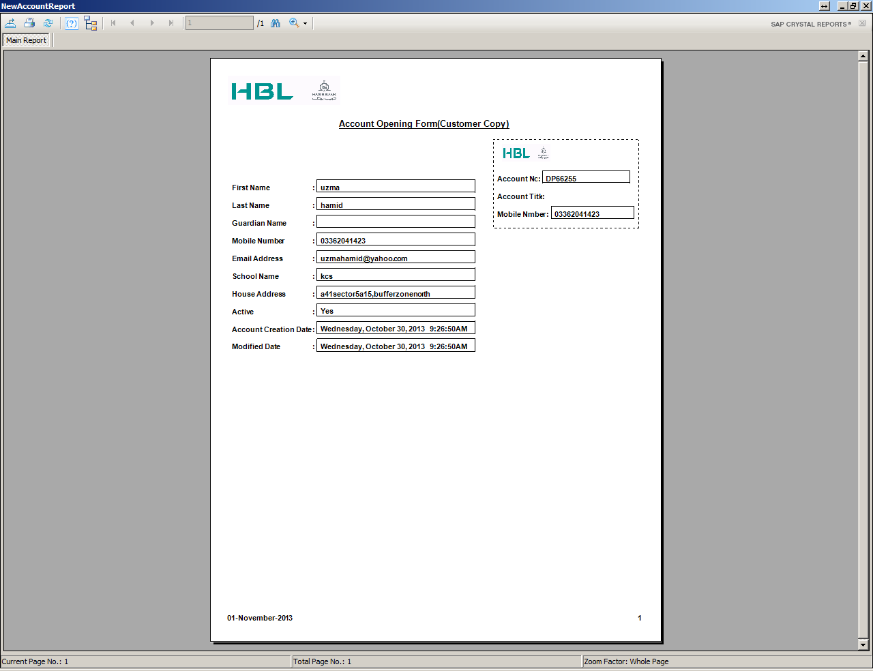

1. **Account Lookup:** The software ‘Bank System’ also facilitates to search an account’s details, to edit an account’s details, to show specific account report, and also to display multiple accounts report using variety of filters like Name, Account No., Phone Number, and their Account Status.

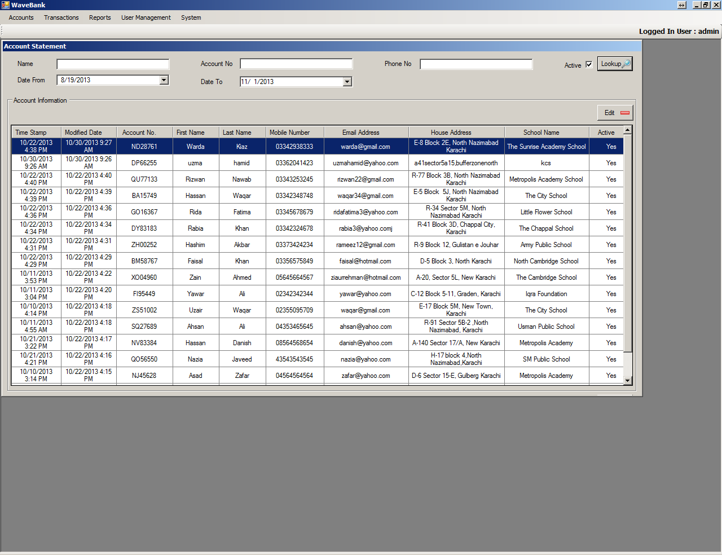

This interface user can also update an existing account.

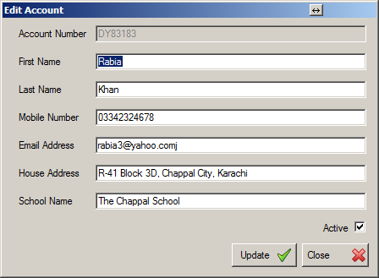

**TRANSACTION**

The software ‘Bank System’ facilitates to perform complete transaction along with searching criteria. This interface also displays the basic information regarding to transaction. The software ‘Bank System’ facilitates our customer to lookup specific account’s details using simple and convenient filters. The interface also includes the basic information of an account’s transactions.

Basically the modules include two:

1. Transaction(Deposit/Withdrawal)
2. Balance Inquiry
3. **Transaction (Deposit/Withdrawal)**: In this interface user can look up via search button click or can get account info when simply enter the information.

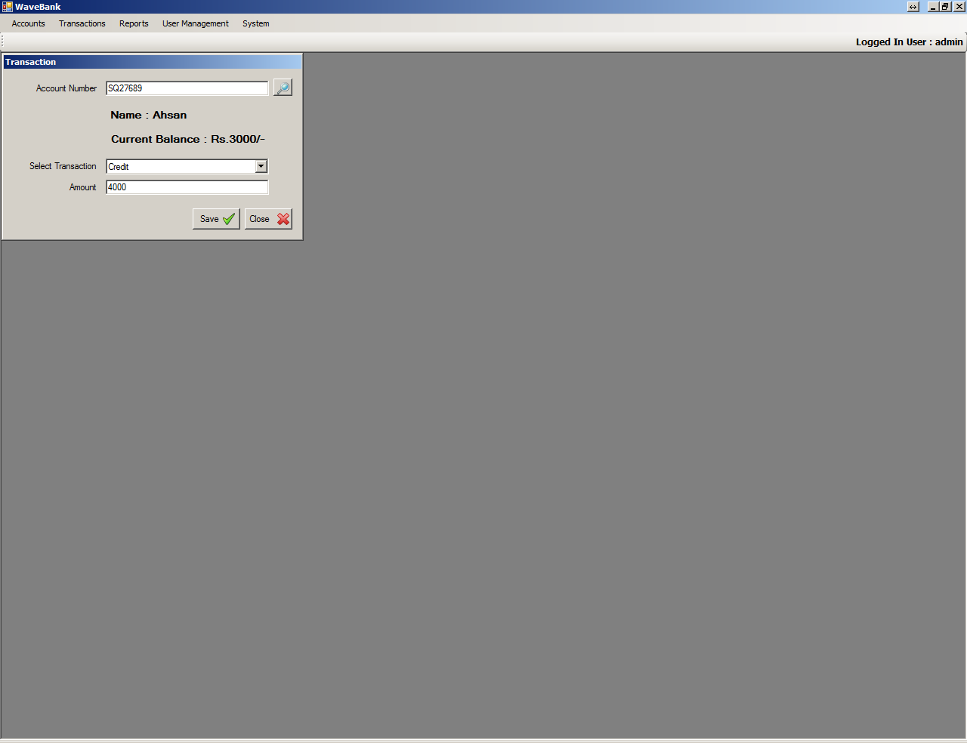

The lookup button click opens a new window to search an account and auto-fill the required fields on selection.

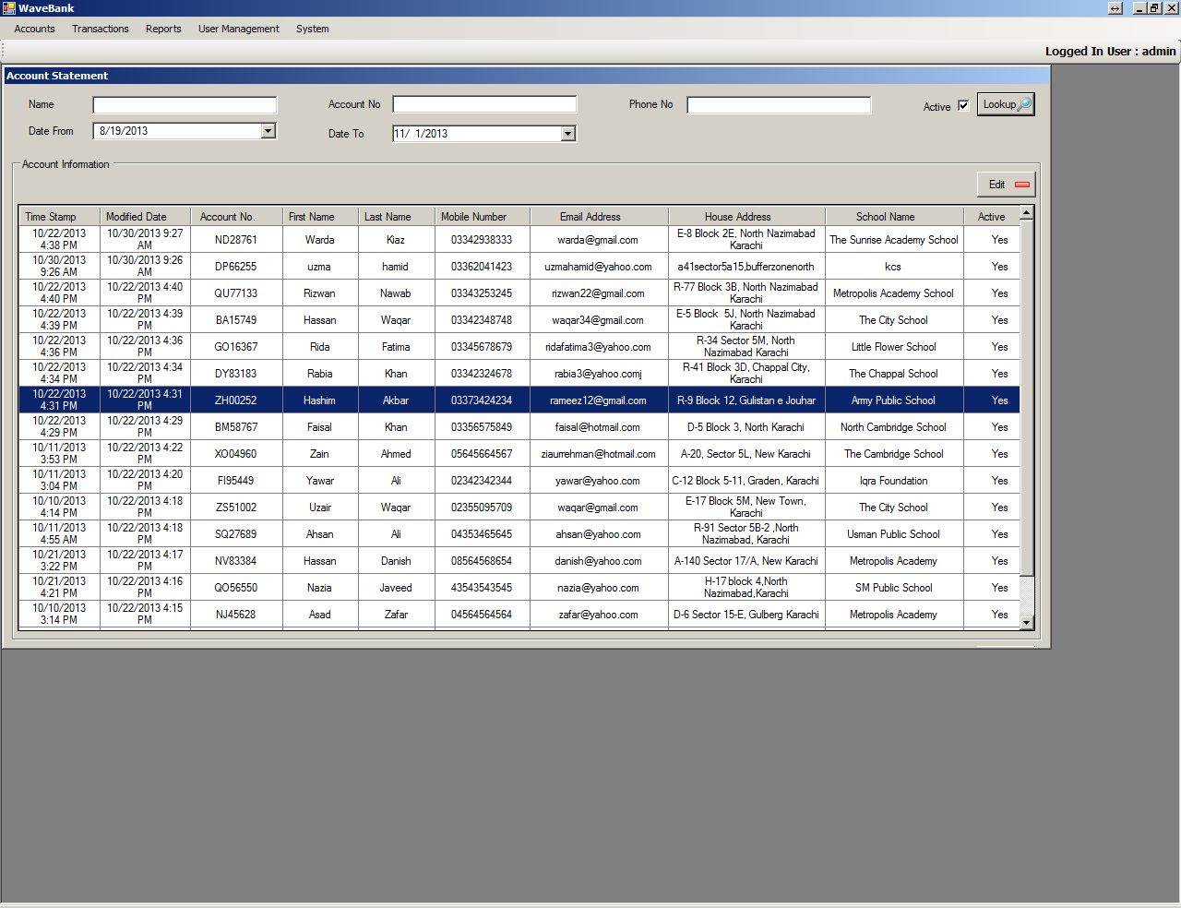

As shown,

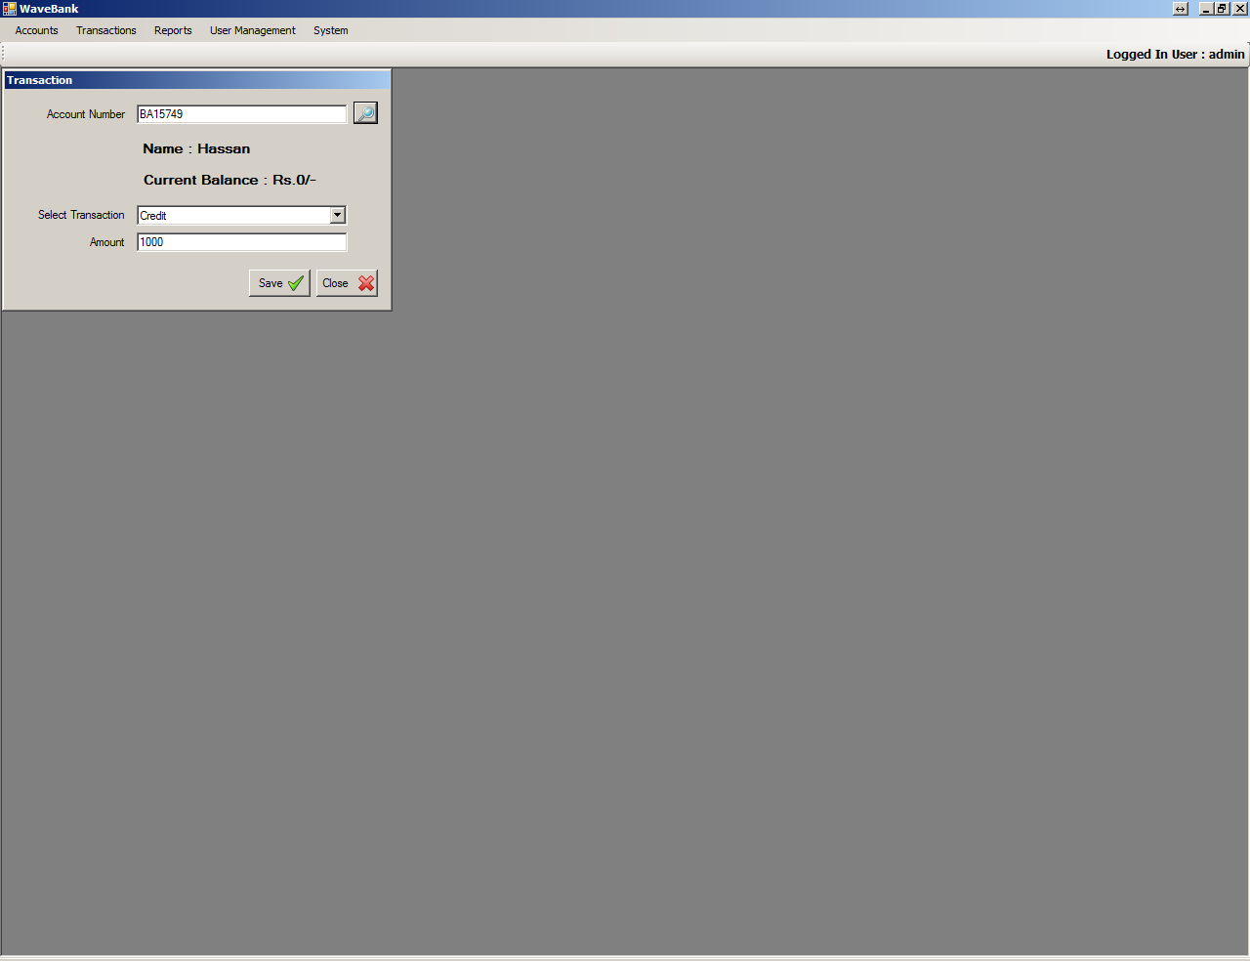

In this way the user would further process for deposit/withdrawal along with current balance.

1. **Balance Inquiry**: Initially this interface also works like Transaction interface. i.e., either will look up the account or will fill the required field to get info.

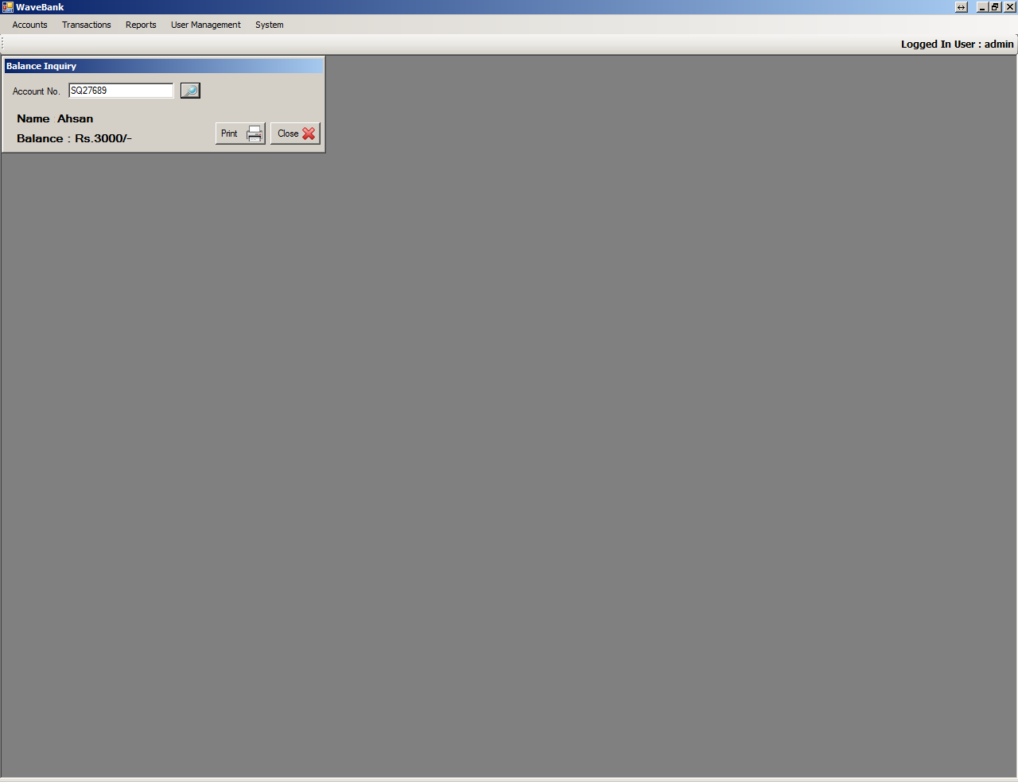

Finally in order to get the balance inquiry report ,user will press the print button.

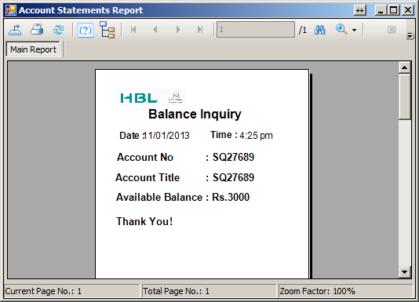

**Statements**

The software ‘Bank System’ facilitates user with convenient interfaces, to filter and execute reports for the ‘Bank System’ solution.

**Account Statements:** In this interface user can search based on account number or at Lookup button click.

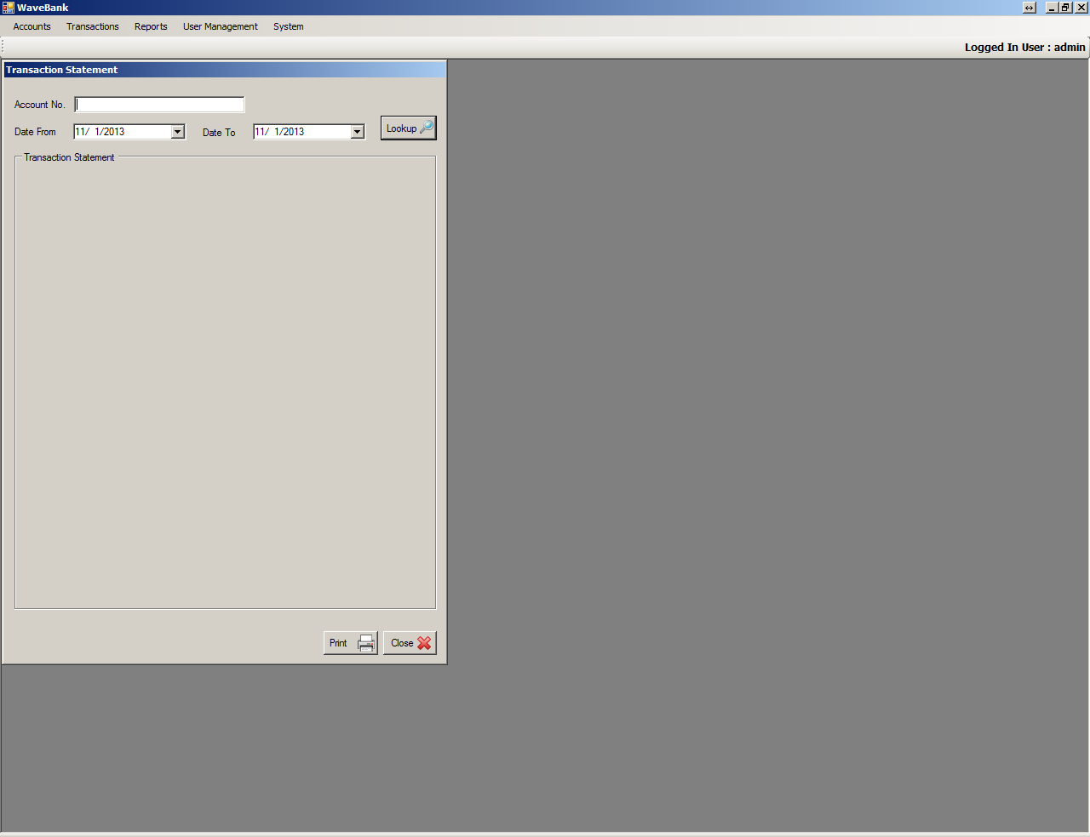

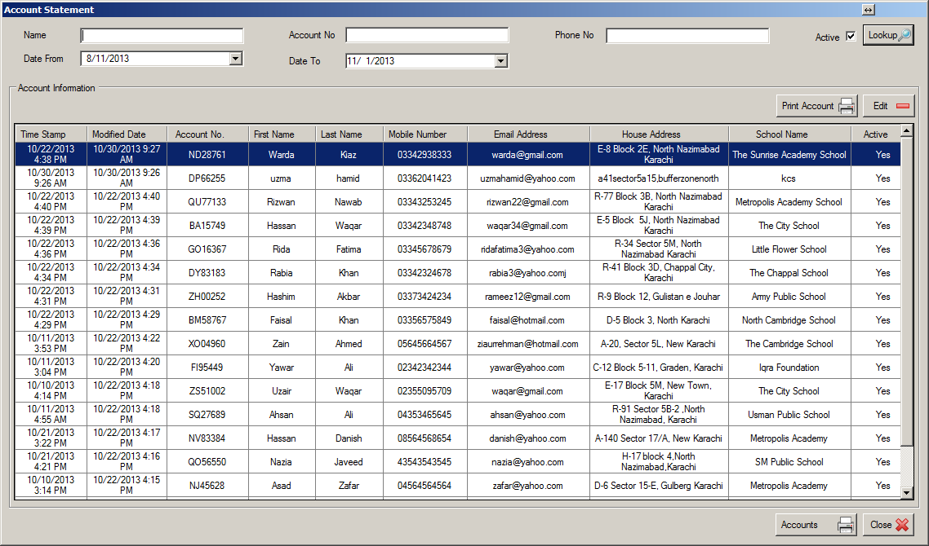

As shown in screen shot below,

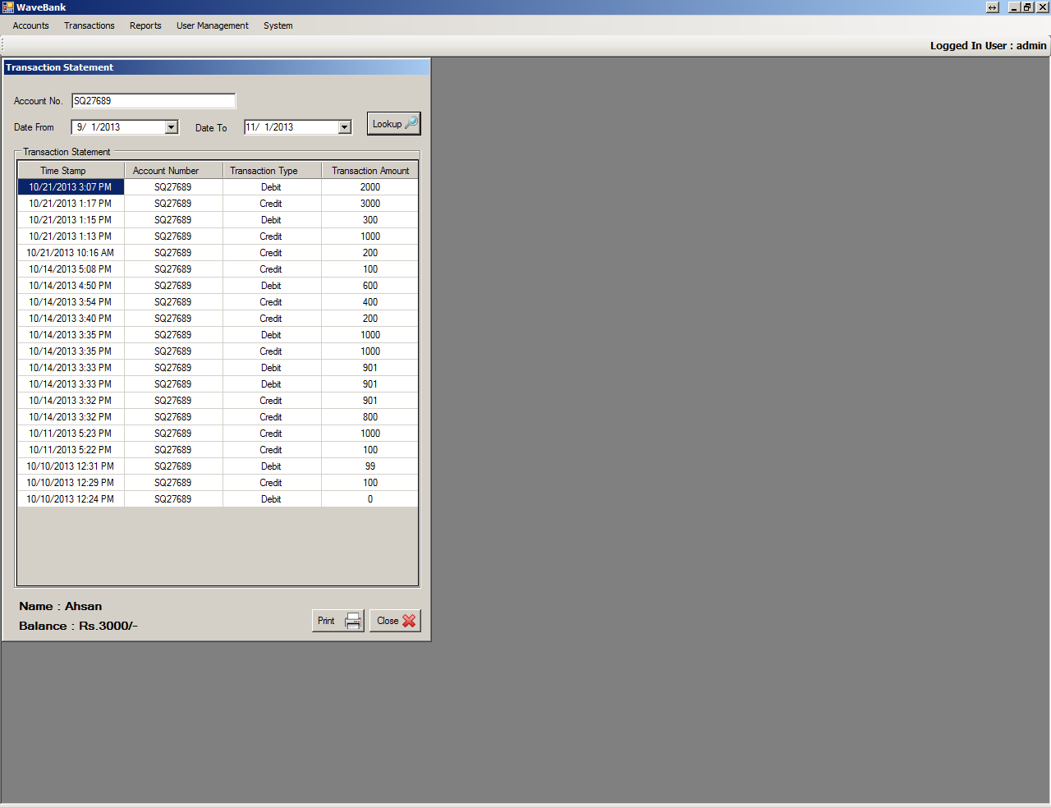

The final of this interface is to display report. So in order to get the account transaction and current balance report user will simply press the ‘Print’ button.

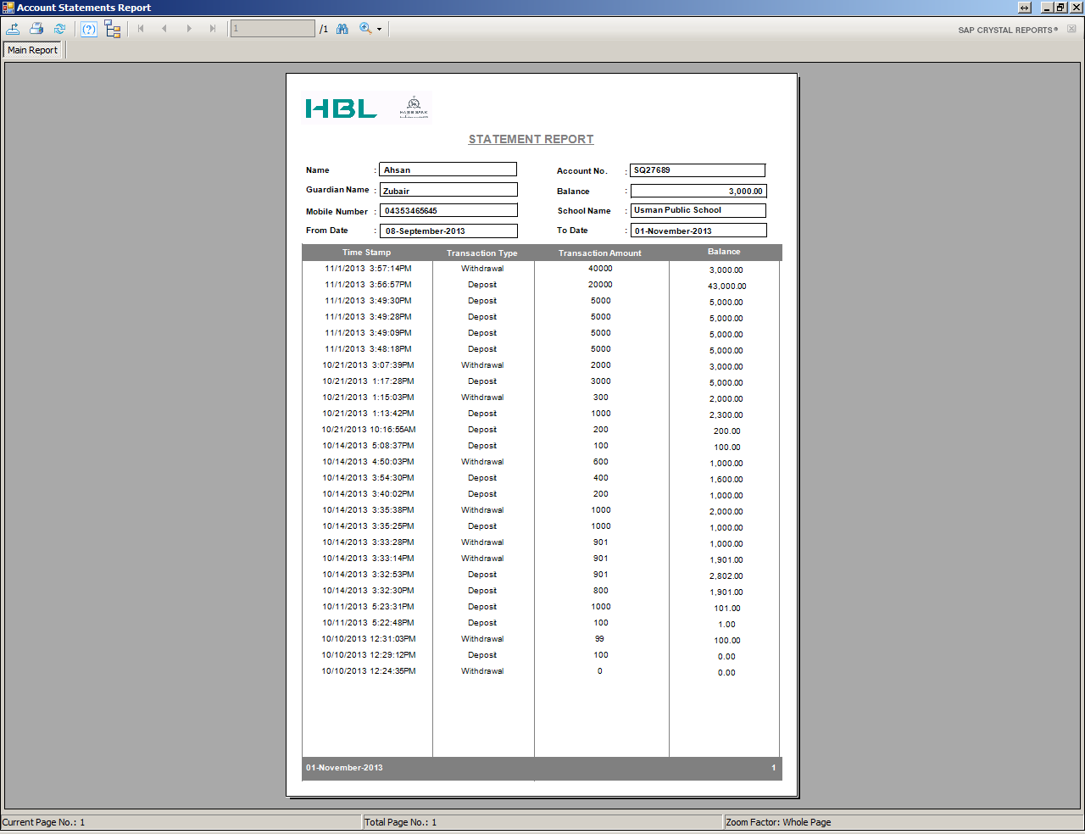

**REPORTS**

The software “Bank System” provides convenient interfaces to display reports using variety of filters. It include the following basic reporting interfaces.

1. Account Creation/Information Report
2. Specific Account Report
3. Transactions/Statements Report
4. Balance Inquiry Report
5. **Account Creation/Information Report:** It executes to display account details.



1. **Transactions/Statements Report:** This report includes current balance amount in the relevant account number.



1. **Balance Inquiry Report:** It executes ‘Balance Inquiry against any account number.

